EX –SERVICEMEN CONTRIBUTION HEALTH SCHEME

Part - I
Introduction
The Ex-servicemen Contributory Health Scheme (ECHS), which is a flagship scheme of the Department of Ex-servicemen Welfare, Ministry of Defence, was launched on 1st April 2003.The Scheme aims at providing Quality Medicare to Ex-servicemen pensioners and their dependents through a network of ECHS Polyclinics, Armed Forces medical facilities and private empanelled/government hospitals spread across the Country. The Scheme is structured on the lines of the Central Government Health Scheme (CGHS) and endeavours to provide cashless treatment to its beneficiaries. Only allopathic treatment is provided under ECHS.
Membership/ Eligibility
1. The Scheme entitles all Ex-servicemen drawing pension from Controller of Defence Accounts, including those in receipt of Disability / Family Pension and their dependents (as applicable under CGHS) to be eligible for membership of ECHS. ECHS membership has also been extended to the following :-

- Territorial Army (TA) pensioners.
- Defence Security Corps (DSC) pensioners.
- Uniformed Indian Coast Guard (ICG) pensioners.
- Military Nursing Service (MNS) pensioners.
- Special Frontier Force (SFF) pensioners.
- Nepal Domiciled Gorkha (NDG) pensioners.
- Whole time NCC Officers.
- Eligible APS pensioners.
- Assam Rifles pensioners.
- WW II Veterans, SSCOs, ECOs & Pre-Mature Retirees.

2. Membership of ECHS has been made compulsory for all pensioners with effect from 1st April 2003 and is optional for earlier retirees.

Contribution
1. The amount of contribution paid for becoming an ECHS member is the same as that of CGHS. Presently, it varies from Rs 30,000/- for Recruit to Rs 1,20,000/- for Officers. The Ex-servicemen who have retired prior to 1st January 1996, war widows and war disabled,including those disabled in internal security duties, are exempted from payment of ECHS contribution.
Rates of contribution presently are as follows:

Ser No | Ranks | One Time  Contribution (in Rupees) | Ward Entitlement
(a) | Recruit to Havs & equivalent in Navy & AF | 30,000/- | General
(b) | Nb Sub/Sub Maj orequivalent in Navy& AF (including Hony Nb Sub/MA)and Hony Lt/Capt | 67,000/- | Semi Private
(c) | All Officers 1,20,000/- Private | 1,20,000/- | Private

Part – II

STATE OF STAFF ECHS POLYCLINIC SHAHPUR

Officer in Charge

S No | Name | Appt | Contact No
1. | Lt Col PC Kaushal (Retd) | Officer in Charge | 9459510408

Medical Staff

S No | Name | Appt | Contact No
1. | Dr Sushil Kumar | Medical Officer | 9418355699
2. | Dr Manvi Thakur | Medical Officer | 9871975037
3. | Dr.Ila | Medical Officer | 9418469689
4. | Dr Milli Dev Sharma | Dental Officer | 7018962624

Para Medical Staff

S No | Name | Appt | Contact No
1. | Neha Sharma | Physiotherapist | 7018316905
2. | Ex Sub Maj Amar Nath | Laboratory Assistant | 9874056687
3. | Gurvinder Singh | Laboratory Technician | 9736191313
4. | Amit Kumar | Dental Technician | 9896176120
5. | Mr Sushil Kumar | Pharmacist | 9418955412
6. | Ex Hav Vijay Kumar | Nursing Assistant | 8437453189
7. | Ex Hav Mohinder Singh | Nursing Assistant | 9988693308
-2-
Non - Medical Staff

S No | Name | Appt | Contact No
1. | Smt Shilpa Dhiman | Clerk | 8988317850
2. | Smt Minakshi Kumari | Female Attendant | 8219529214
3. | Ex Hav Rakshpal Singh | Driver | 9478930519
4. | Mr Lakhan Chandel | Safiwala | 7018597920
5. | Ex Hav Sanjeev Kumar | Chowkidar | 7018043214
6. | Ex Hav Ravi Kant | Peon | 8627051935

Part - III
FACILITIES IN ECHS POLYCLINIC SHAHPUR

PHYSIOTHERAPY

Physiotherapy is an integral part of healthcare focusing on pain relief, rehabilitation, and functional improvement using various therapeutic modalities.

Short Wave Diathermy (SWD)
- Provides deep heating to tissues
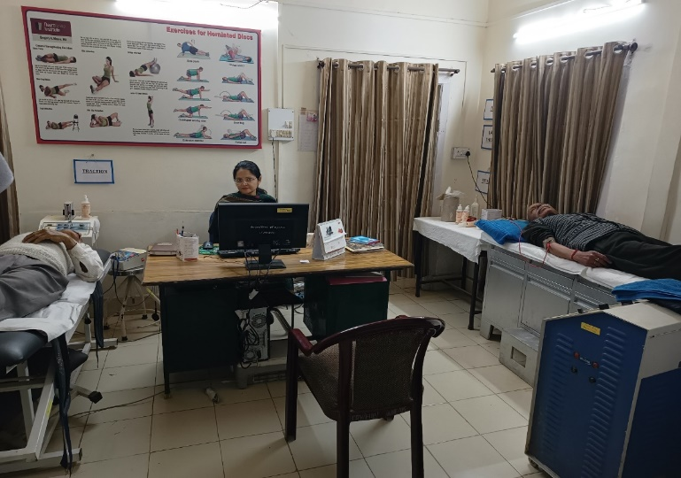
- Reduces pain and inflammation
- Relaxes muscles
- Promotes tissue healing

Wax Bath Therapy
- Reduces post-injury stiffness
- Improves joint mobility and flexibility
- Relieves pain in arthritis and fibromyalgia

Hot Packs / Hydrocollator
- Produces superficial tissue relaxation
- Improves blood circulation
- Reduces muscle spasm

Traction (Cervical & Lumbar)
- Reduces nerve root compression
- Improves spinal alignment
- Relieves pain in disc prolapse, sciatica, and arthritis

Interferential Therapy (IFT)
- Provides pain relief
- Reduces inflammation and swelling
- Promotes muscle relaxation

TENS
- Used in back pain
- Effective in OA, fibromyalgia, tendinitis, bursitis
- Helpful in chronic pain conditions

Laser Therapy
- Reduces inflammation
- Accelerates healing
- Improves circulation

Infrared Radiation (IRR)
- Improves local blood circulation
- Reduces muscle stiffness

Multiexercise Chair
- Used for rehabilitation
- Strengthens shoulder and quadriceps muscles
- Improves functional mobility

IASTM
- Used in tendinitis
- Effective for soft tissue and fascial restrictions
- Helpful in sports injuries and scar tissue management
Conclusion : Proper use of physiotherapy modalities enhances recovery and functional independence.

LABORATORY

EQUIPMENTS | SECTION | LAB TEST FACILITY
Haematology ERBA H360 Part Analyzer | Haematology | Hb, TLC, DLC, Platelets, Complete Haemogram
Biochemistry ERBA Chem-7 Analyzer | Biochemistry | Sugar, Urea, Creatinine, Uric Acid, Total Protein, Albumin (RFT/KFT), Total Bilirubin (Direct + Indirect), SGOT, SGPT, Alkaline Phosphatase (LFT), Total Cholesterol, Triglycerides, HDL Cholesterol (Lipid Profile), Calcium
Laura Smart ERBA Urine Analyzer | Urine Chemistry | Specific Gravity, pH, Sugar, Protein, Bile Salt, Bile Pigment, Nitrate, Ketone Bodies, Blood, Leukocytes
Oncall A1C Accon Analyzer | HbA1c | HbA1c Blood Test
On Slide Tests | - | RA Factor, CRP, Widal Test
Binocular Microscope | Microscopy | Hemat DLC, Parasites, Urine Deposits Microscopic Examination
The above mentioned routine tests are available and are being performed in the laboratory of ECHS Polyclinic Shahpur

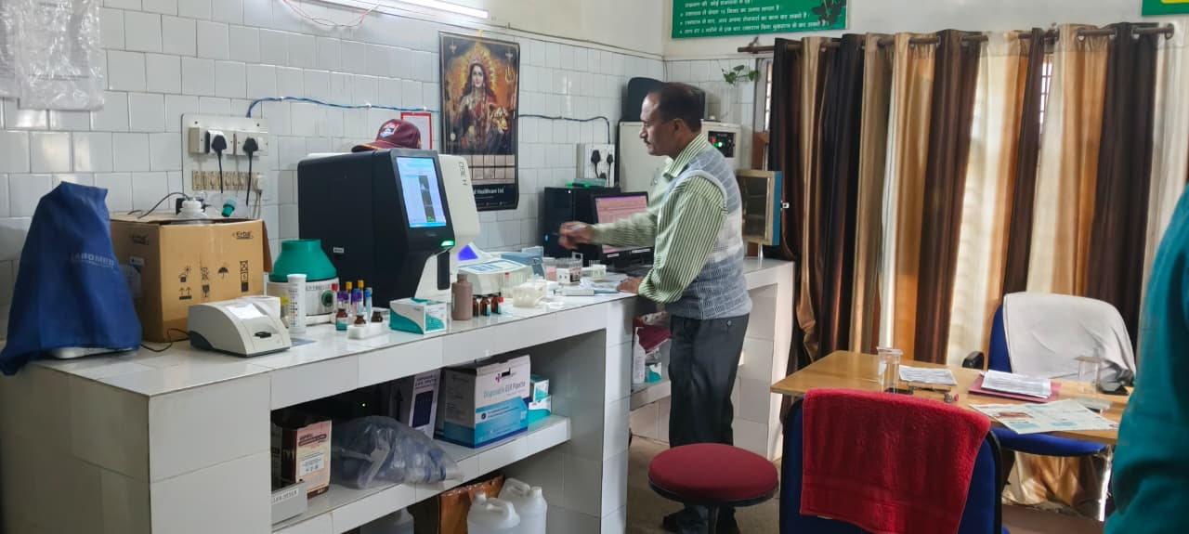
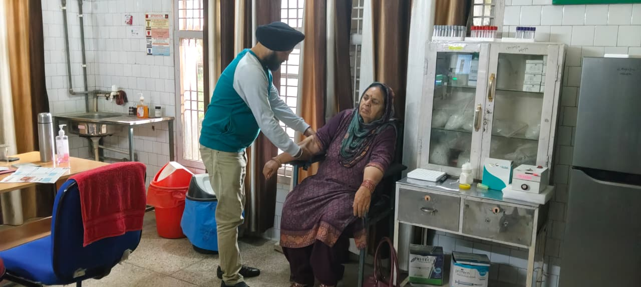

DENTAL FACILITIES:

- Root canal treatment (anterior / posterior)
- Restoration of decayed teeth
- Extraction of grossly carious teeth
- Surgical extraction of wisdom teeth
- Scaling and oral prophylaxis of teeth
- Complete diagnostics including X-ray
- Complete and partial dentures fabrication
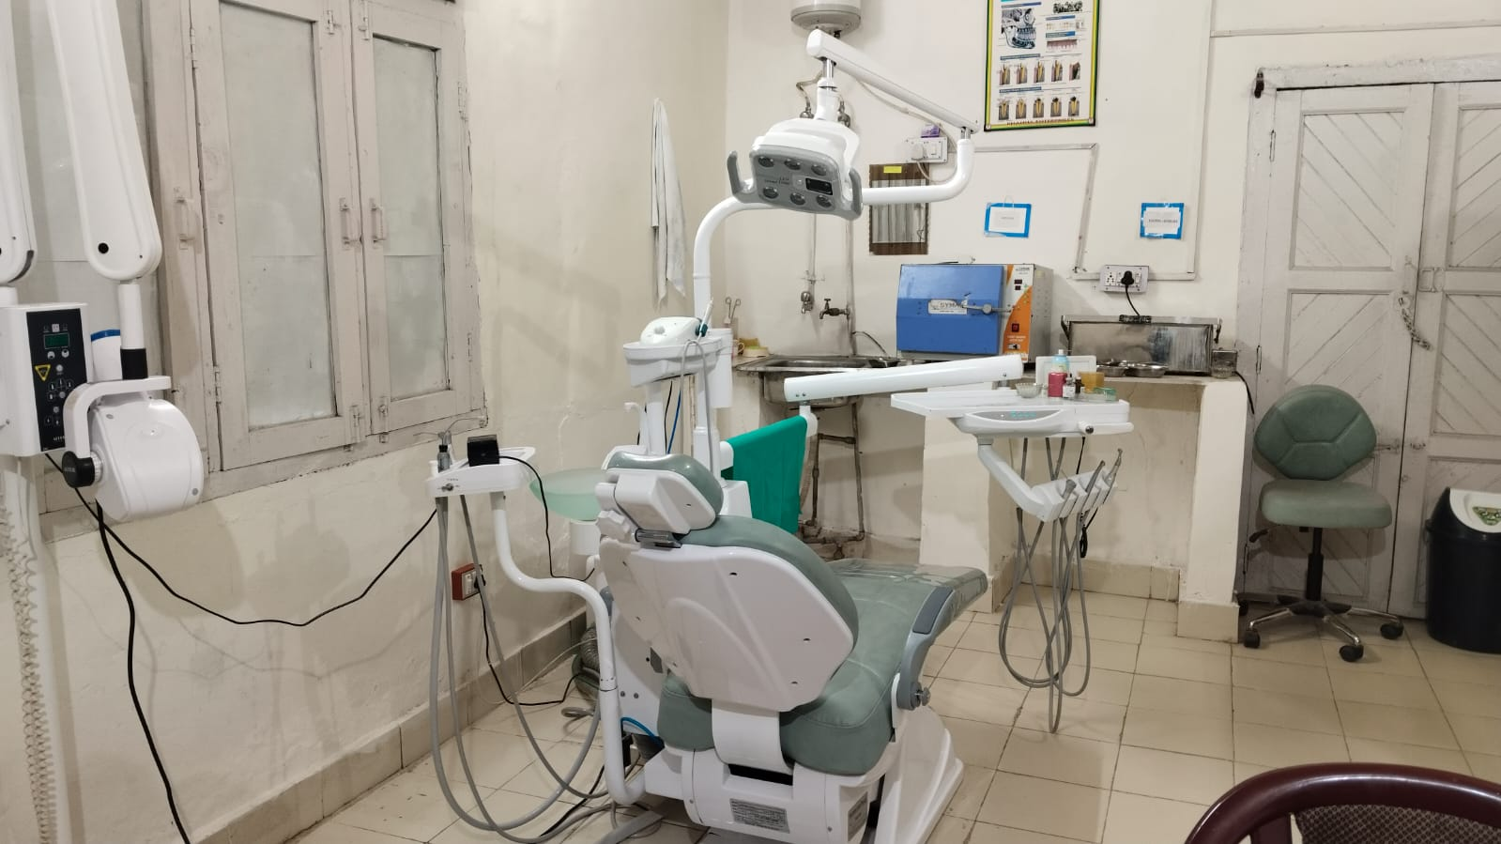
- Repair of broken prosthesis

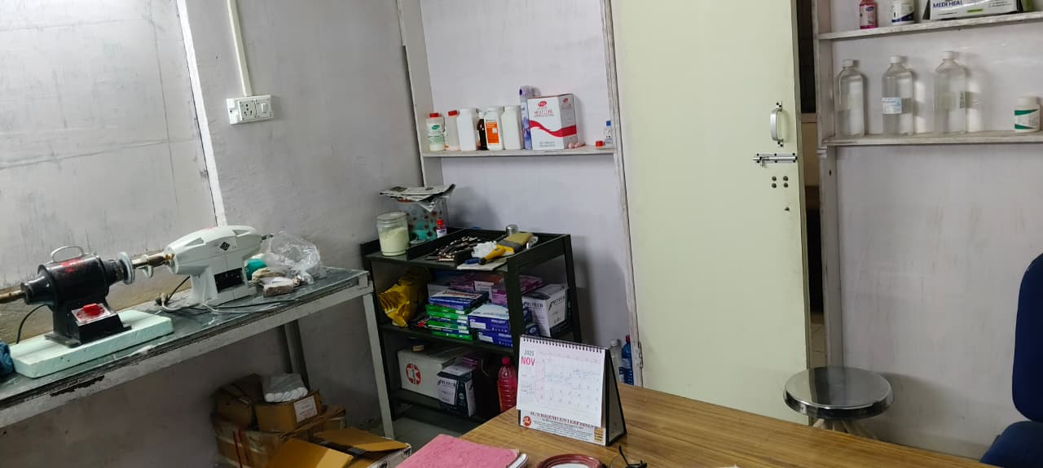
Part - IV

PROCEDURE OF ONLINE APPLICATION FOR ECHS CARD
Preparation
1. Scan the following and save each document in separate file of JPEG,of 1 MB max, for uploading :-

- Pension Payment Order (PPO) of Primary Beneficiary, i.e., Ex Service MAN (ESM) if he is alive or his Wife, if ESM is not alive.

- Old ECHS Card (front side only) / Temporary Slip of Primary Beneficiary
- Photo of Primary Beneficiary (Passport size colour photo in white background)
- Signature in Blue Ink, of Primary Beneficiary
- Photos of Dependants (Passport size colour photo in white background)
- Signatures in Blue Ink or Thumb Impressions of Dependants
- Death Certificate of ESM, if he is not alive
- Disability certificate of ESM, if disability is battle disability.
- Disability certificate of dependent(s) if dependent(s) have disability

2. For first time application of pre 2003 retiree:-

- DPDO/ Bank certificate, certifying that FMA (Fixed Medical Allowance) has been stopped.
- MRO receipt for ECHS membership fee, for those retired from 1996 to 2002.
3. Keep the following ready, for information to be filled in the Application:-

- Aadhaar and PAN Cards of Primary Beneficiary &Aadhaar Cards of all dependants
- PAN cards of dependents if available
- Bank Pass Book of pension account & ESM Discharge Book
- Permanent and Temporary address of Pensioner
- Blood group of ESM and all dependents
- Debit or Credit Card and it’s linked phone to get OTP and make payment of Application Fee online (Rs 177/- per card)

- Email Id, if available, for retrieving Password etc.

4. Registration

- Go to web site https://echs.gov.in and Click “OK”
- Select “ ONLINE SMART CARD APPLICATION”
- Select “ ONLINE APPLICATION” and Click “OK”
- Then, Register Application, keeping the following points in mind:-

  - If there is no Prefix, leave it blank &. If there is no suffix, Put’ $’, in the space.
  - Enter Mobile Number, which should be active to receive OTP immediately and all the messages regarding the ECHS Card subsequently.

  - Create your password. Keep this Mobile Number and Pass Word with you, till your ECHS Card is received, so that you can see the progress and observations on the application, if any, during the processing of ECHS Card.

  - Enter Mother’s Name & Place of Birth of Pensioner. Note down these with correct spelling, including Capital/ Small letters. These can be used to retrieve/ change password.

-2-

  - Click “REGISTER”. Message will appear as “Registration done successfully”. Click OK.
  - Login page will open. Login using Mobile No and Password given. OTP will be sent to Registered Mobile and mobile verification page will open. Enter OTP and click “Verify”.

  - Message of “MOBILE NUMBER VERIFIED” will be displayed.
5. Filling the Application Form Online
- Go to web site https://echs.gon.in. Click “OK”
- Select “ ONLINE SMART CARD APPLICATION”
- Select “ ONLINE APPLICATION”
- Click “OK”
- Click “ALREADY REGISTERED. CLICK TO LOGIN”
- Select the Application Category by clicking “Drag down Icon, small arrow”
- Fill in the EX SERVICEMAN (ESM) DETAILS.
- Upload Photo & Signature of Primary Beneficiary
- Enter other details of Primary Beneficiary
- Upload Photos/ Signatures and other details each dependant.
- Upload PPO, Old ECHS Card of Primary Beneficiary
- Upload Death Certificate, if ESM is not alive
- Upload Temporary Slip and other documents, if applicable.
- Agree the SELF DECLARATION by clicking “ I AGREE”
- Save the details entered by clicking “SAVE DETAILS” Saved details can be modified or corrected if necessary by logging in once again and saving the corrected details.

- Make Payment by Clicking “MAKE PAYMENT” and giving other details asked.
- Take Print out of Application Form, Payment Receipt and Temporary Slip, by logging in, after Payment of Fee. Note down Phone Number, Password, Mother’s Name and Place of Birth at the end of Application printed, for future reference.

- Get the Signature of OIC ECHS on the Temp Slip, Which can be used as ECHS Card, till you receive the NEW ECHS CARD.

- Check for Observations if any from Record Office, by logging in frequently till the application is verified by Record Office concerned. Sort out the observations by suitable actions and change your details by Editing your application, if necessary. Save details once again after editing the application.

- Wait for SMS giving OTP for collection of NEW ECHS Cards, to be collected from Station Headquarters.

